RIVERSIDE ELEMENTARY SCHOOL

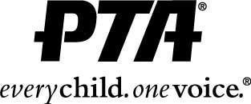

Activity Interest Sheet

Get involved and make a difference. The following is a list of activities for the 2019-20 school year. Everyone is welcome and encouraged to become involved! This is not a commitment. We use your information to contact you for possible assistance throughout the school year.

Thank you for your participation!

Name

Address

Phone

E-mail

Child/Children’s Names, Grades, Teachers ___________________________________________________
_______________________________________________________________________________________

Committees of Possible Interest

__________ | Book Fair – assist with set-up, selling books and/or tear down in the Fall or Spring
__________  __________  __________ | Family Fun Night – help with end of the year celebration for students (collect money, serve food, run games/events)  Fundraiser – help sort, count out, distribute, etc  Homecoming Float Decorating
__________ | Hospitality – assist with planning meals for teachers during conferences and Teacher Appreciation Week
__________ | Santa’s Craft Workshop – help set-up and run the workshop for the students to make various gifts for holiday gift giving
__________ | Social – Help organize and promote various social events (Ice Cream Bingo, Snowball Dance, etc.)
__________ | Call me to provide baked goods as needed
__________ | Call me to help for an hour or two as needed for PTA activities

Please return this form to the PTA table at Meet the Teacher Night, school office, or any PTA meeting.

